Learn the Meaning of below

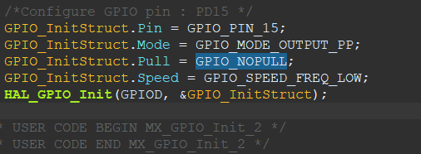

Answer:-

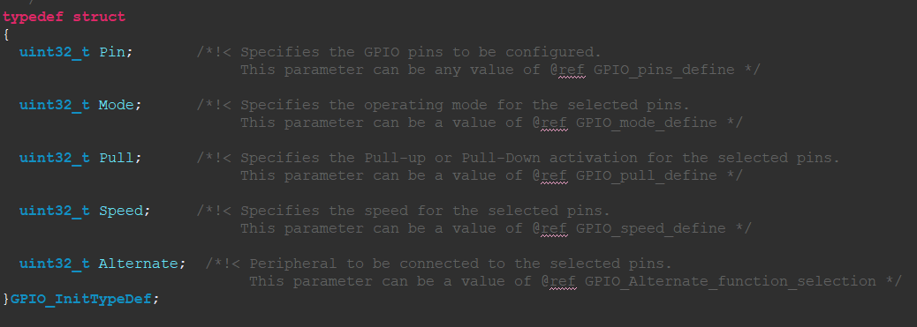

<https://embeddedartistry.com/blog/2018/06/04/demystifying-microcontroller-gpio-settings/>

<https://electronics.stackexchange.com/questions/156930/stm32-understanding-gpio-settings>

learn risc , cisc

clock arbritration ,clock switching

risc and cisc

<https://www.geeksforgeeks.org/computer-organization-risc-and-cisc/>

clock arbritration and clock switching

<https://www.i2c-bus.org/i2c-primer/clock-generation-stretching-arbitration/>

system calls

<https://www.geeksforgeeks.org/introduction-of-system-call/>